Granville Island Busking Program

2024/2025

CMHC-Granville Island acknowledges that we are located on the traditional and unceded territories of the Musqueam, Squamish and Tsleil-Waututh First Nations.
Managed by CMHC-Granville Island

Table of Contents
INTRODUCTION 3
Granville Island History 3
Busking at Granville Island 3
PROGRAM OBJECTIVES 4
PROGRAM MANAGEMENT 4
Rule Enforcement 4
Dispute Resolution 5
Performance Locations 5
Major Events & Public Holidays 5
WHAT IS BUSKING? 5
What makes a good busker performance? 6
GENERAL POLICIES 7
Professionalism 7
Performance Variety 7
Pedestrian Access/Audience Management 7
Selling Merchandise 8
Legal and Copyright 8
Possession of License 8
Minors 8
Start and End Times 8
No-Shows 8
DIVERSITY, EQUITY AND INCLUSION 8
CODE OF CONDUCT 9
HEALTH AND SAFETY 9
BUSKER APPLICANTS 9
Auditions 9
Registration 10
Acceptance 10
LICENSE INFORMATION 10
License Types 10
Pricing 10
License Upgrades 11
License Replacement 11
License Renewal 11
Re-auditions 11
ALL ACCESS LICENSES 11
Musicians 11
Circle Acts 12
Variety Acts 12
Individual Acts vs Group Acts 12
GROUP LICENSES 12
Musician Groups 12
Variety Groups 12
THE MORNING DRAW 13
PERFORMANCE LOCATIONS 13
ACOUSTIC LICENSES 14
Musicians 14
Variety Acts 14
Individual Acts vs Group Acts 14
Indoor Acoustic Locations 15
Outdoor Acoustic Busking 15
APPENDIX: INSTRUMENT LIMITATIONS 15
Accordions 15
Amplified Flutes 15
Bagpipes 15
Brass Instruments 15
Percussion Instruments 16
String Instruments 16
Use of Backing Tracks 16
APPENDIX: NON-MUSICIAN LIMITATIONS 16
APPENDIX: ELECTRICAL POWER 16
APPENDIX: SOUND LEVELS (AMPLIFIED AND ACOUSTIC) 17
APPENDIX: FIRE & DANGEROUS PROPS 18

INTRODUCTION

MISSION STATEMENT
“To steward this public land for meaningful urban and social experimentation among diverse, creative, cultural, and business models, engaging local First Nations and communities while welcoming the world.”

VISION STATEMENT
“The most inspiring public place in the world.”

Granville Island History

Granville Island (initially known as “Industrial Island”) was filled in over a tidal mudflat using sand dredged from False Creek in 1912. The area was originally abundant in wildlife and inhabited by Salish communities for thousands of years. After the island was filled in, manufacturers wanting valuable access to the water quickly moved in.

In the 1970s, Granville Island began its successful transformation from what some called an “industrial wasteland” to one of the most beloved public spaces in Vancouver, celebrated internationally as a model of vibrant urban placemaking. As Vancouver’s premier artistic and cultural hub, located in an urban waterfront location and steeped in a rich industrial and maritime heritage, this unique destination attracts millions of visitors each year from Vancouver and around the world.

The charm of Granville Island lies in its mix of uses. The famous Public Market (opened in 1979), open daily, is home to more than 50 independent food purveyors and contributes to the Island’s appeal as a renowned culinary destination. You can find some of Canada’s best artists and designers in the Net Loft Shops and Artisan District. Granville Island is home to many cultural venues and hosts numerous performing arts and cultural festivals year-round.

Although federally owned, Granville Island is financially self-sustaining with revenues generated from leases and parking fees, and home to more than 300 businesses that employ more than 3,000 individuals.

Busking at Granville Island
Granville Island is proud of its reputation for supporting lively street culture and values the diversity of entertainment that buskers provide in the public realm. Artistic and cultural life is integral to Granville Island’s creative environment as it encourages performers to showcase their craft. Granville Island is committed to providing a safe, accessible, and culturally sensitive environment for all.

The Granville Island Busking Program welcomes local, national, and international artists who specialize in creating accessible entertainment for all ages.

Granville Island recognizes the valuable contribution street entertainment and busking performances make to the life and vitality of the Island. The Granville Island Busking Program provides a policy framework to assist performers, businesses, and visitors in understanding the rules for busking and creating an unforgettable experience for our guests.

PROGRAM OBJECTIVES

The objectives of the Granville Island Busking Program are to:

- Support and encourage busking performances that enhance the vibrancy, vitality, diversity, and ambience of the Island
- Provide a fair and transparent framework to manage busker activities on Granville Island that allows all program participants an equal opportunity for success
- Maintain the Island’s identity as a cultural oasis and add to existing levels of public appeal
- Maximize positive feedback associated with the Busking Program

PROGRAM MANAGEMENT
CMHC-Granville Island manages the Granville Island Busking Program. All queries and concerns about busking on Granville Island should be made directly to CMHC-Granville Island. CMHC-Granville Island retains the right to change or amend the Regulations at its own discretion at any time without prior notification. CMHC-Granville Island also reserves the right to refuse to issue a license to an individual or group at its own discretion and without further justification.

CMHC-Granville Island  1661 Duranleau Street, 2nd Floor  Vancouver, BC  V6H 3S3 | Busker Hotline: 604-834-1567  www.granvilleislandbuskers.com  buskers@granvilleisland.com

Rule Enforcement
The Granville Island Busking Regulations are enforced by a three-strike system:

1st offence: the busker will be given a “verbal” warning. Should the busker not be onsite to receive a “verbal” warning, the warning will be given over the phone or through email.

2nd offence: the busker will receive an email addressing the behaviour that requires change.

3rd offence: revocation of a busker’s license.

Busking activities with a revoked license will be considered trespassing.

CMHC-Granville Island Staff reserve the right to cancel, at their discretion, and without notice, any performance that is deemed to be inappropriate or disruptive. Certain behaviour such as physical or verbal abuse to anyone on Granville Island, including fellow buskers, will result in disciplinary action or the revocation of the busker license.

Inappropriate behaviour includes but is not limited to intoxication, intimidation, swearing, yelling, heckling passers-by, belligerence, harassment, manipulation, and general disrespect towards fellow buskers and/or CMHC staff.

If a Busker decides to re-apply in the future and is accepted into the program, the license issued will have conditions attached.

Dispute Resolution
If any conflict arises between fellow buskers, merchants, or guests, the busker should immediately contact the Busking Program Coordinator by calling 604-834-1567. All aspects of dispute resolution are to be conducted through CMHC-Granville Island.
Performance Locations
At CMHC-Granville Island’s discretion and without prior notification, locations may be restricted, moved, or become temporarily unavailable. Buskers must follow the direction of CMHC-Granville Island staff and security if any busker location becomes unavailable either temporarily or permanently.
Every effort will be made to provide advance notice by email, but advance notice cannot always be guaranteed.
Reasons for the temporary or permanent closure of performance locations can include:
- CMHC programmed events
- Construction and/or renovations to buildings and streets
- City of Vancouver construction projects

Major Events & Public Holidays
Specific restrictions or blanket cancellation of busking may be imposed during planned major events or public holidays throughout the year. In the case of an organized event, performers must not attempt to associate themselves with that event unless otherwise advised or invited by an event organizer.
Please note that Granville Island is closed on the following public holidays and therefore busking is not permitted:
- December 25th: Christmas Day
- December 26th: Boxing Day
- January 1st: New Year’s Day

WHAT IS BUSKING?
On Granville Island, a busker is an entertainer who is actively providing a public performance in a public space in exchange for tips.
Types of busking performances welcome at Granville Island include:
- Performing with an instrument or multiple instruments, conventional or self-constructed
- Performing a song, dance routine, mime, clowning, juggling, puppetry, comedy, magic or living statue act
- Performing a Circle Show (refer to Circle Show definition, Page 12)

What makes a good busker performance?

Diverse & Engaging
Busking must offer a variety of performances, positively engage passers-by, and create a sense of interest and curiosity.

Safety & Ambience
The performance must always provide a sense of safety and security and must never put the performer, audience, or passerby at risk of injury. It must not compromise the ambience of the area by way of excessive amplification or anti-social behaviour. Lastly, busking must be integrated into the location in a way that does not compromise circulation requirements. This includes other activities, pedestrian or traffic safety and ensures adequate clearances.

Level of Proficiency
Buskers must demonstrate a high degree of proficiency in their performances. CMHC-Granville Island reserves the right to assess levels of proficiency and suspend performing privileges if the busker is unable to consistently meet the necessary standard.

GENERAL POLICIES

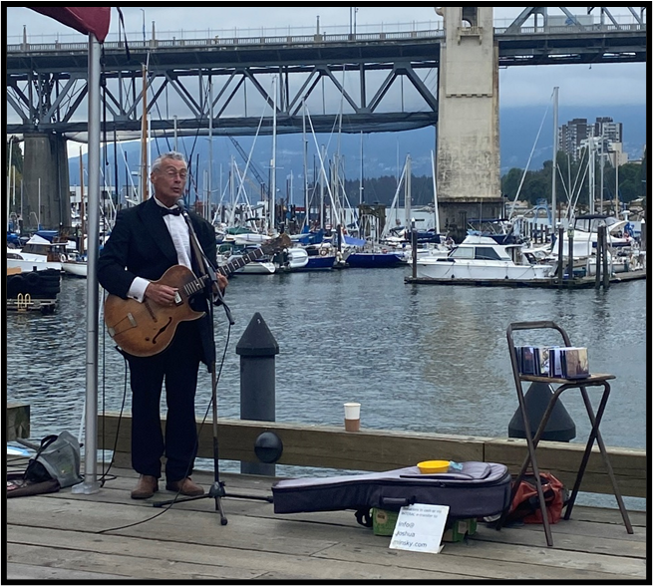
Professionalism
Buskers performing on Granville Island must conduct themselves like they would at any customer service-oriented job.
All performers much adhere to the following professional guidelines:
- The performer must be punctual and prepared.
- The performer must ensure that their equipment is in good working order and sound levels are within CMHC-Granville Island’s established levels (see Appendix: Sound Levels).
- The performer believes in communication, mutual respect, and co-operation not only with their peers, but the Granville Island community at large.
- The performer must demonstrate respect for the space in which they are busking and leave it in the same condition it was found.
- Between performance times, a busker must continue to conduct themselves professionally. This includes maintaining positive interactions with the public and Granville Island staff. While the busker does not represent Granville Island, they do represent the busker program.

Performance Variety
Buskers must vary their set lists daily to avoid repetition. The same song cannot be played more than once in each set.

Buskers who routinely play three or more days per week need to have three or more hours of performance-ready repertoire and must vary their set lists daily to avoid repetition.

CMHC-Granville Island reserves the right to further regulate repertoire at all locations. Popular songs, such as “Hallelujah”, may be regulated by CMHC should it receive enough complaints from the public regarding its frequency.

Pedestrian Access/Audience Management
Buskers are responsible for always maintaining pedestrian flow and crowd control. This includes free and safe access for pedestrians along any pathways or thoroughfares near the performance site.

Performers must ensure that they and their audience do not block shop doorways during business hours, dining areas and cafes, bus stops, fire escapes, or roads. Performers must also ensure that wheelchair access around a site is preserved.

Buskers must ensure that the audience does not block or impede traffic in any way. Buskers must actively move people audience members off the road during their performance.
Groups or individuals not respecting these guidelines may be asked by Security or the Busker Coordinator to stop their performance. A non-performing member of the group may be needed to ensure that the audience does not occupy roadways.

Selling Merchandise
The selling of merchandise on Granville Island may only be done during a busker’s timeslot. Permitted merchandise is limited to recordings, of the busker’s own work. Prior to selling a recording, buskers must supply CMHC-Granville Island with one copy of each recording.

Legal and Copyright
Buskers must ensure that they are legally entitled to perform in Canada, whether as a citizen, permanent resident, working visa holder, etc.
Buskers must obtain all performance material rights and permits.

Possession of License
Buskers must be always in possession of their busking license when carrying out busking activities on Granville Island. Lost licenses must be reported to the Busker Coordinator as soon as possible.

Minors
Buskers under the age of 18 must have a parent or guardian present with them at the time of registration to co-sign the registration form.
Buskers under the age of 16 must have a responsible adult with them at all times while performing on Granville Island.

Start and End Times
Setup and strike MUST happen within the allotted set times - NO EXCEPTIONS.
Under no circumstance may a busker set up or start their set early. They also must not stay beyond their end time: this includes not being a physical presence on or near the pitch so that there is no distraction for the next busker. Even if there is no busker scheduled immediately after a busker’s set, the same rule applies. Regardless of what activity is taking place, staying beyond the end time is a violation.

No-Shows
If a busker is late or doesn’t arrive to a set, the location will be held for a maximum of 10 minutes before it is opened to other buskers. Buskers who need to cancel their timeslot must contact the Busker Coordinator at 604-834-1567. Buskers wishing to use unclaimed spots must contact the Busker Coordinator prior to performing. In all cases, the one-set-per-location-per-day rule and instrument restrictions still apply.

DIVERSITY, EQUITY AND INCLUSION
Every day CMHC-Granville Island works to create and foster a diverse, equitable and inclusive environment for everyone who works and plays on the island. This mission is extended to the Busker Program.
Upon acceptance to the program, should a busker require accommodations, CMHC–Granville Island staff will work with said busker to the best of their ability.

CODE OF CONDUCT
By joining the Busking Program, buskers are committed to contributing to a mutually respectful and safe environment.
This includes:
- Treating others in a courteous and professional manner in all modes of communication.
- Refraining from uttering offensive remarks, language, jokes, bullying, threats, or violence.
- Considering the impact of their performance on others in a broader social and cultural context.

HEALTH AND SAFETY
By joining the Busker Program, buskers are committed to providing a safe environment for the public, merchants, Cultural Partners, CMHC staff and themselves while performing.
If there is an emergency, a busker must call 9-1-1 first and request an ambulance, then Granville Island Security: 604-315-3003.
Buskers must call security if they experience:
- Theft
- Assault
- Threats of violence
- Interference with a performance
Buskers may cancel a performance out of concern for health and safety. A busker must call the Busker Coordinator immediately to inform them of risk of health and safety.

BUSKER APPLICANTS

Auditions
While applications are accepted throughout the year, auditions for all license types are held twice per year, in April and September. Applicants will be adjudicated based on the performance guidelines on page #9.
Applicants should be prepared to perform at least 20 minutes of material for the adjudication panel. The content should be the same as the applicant intends to perform while busking at Granville Island. All material should be “performance ready” and not “in the works” or “in rehearsal.” An applicant may or may not receive notes on their performance.
If an applicant intends to perform any material including fire or dangerous props, they will be asked to provide proof of insurance and relevant permits ahead of their audition.
Registration
Once registered, a busker license is valid until April 30 of the following year. Annual registration is required. We do not offer pro-rated fees. Licenses are non-refundable and non-transferable.

The Busking Year starts on May 1 and ends on April 30 the following year. License applications and fees for the New Busking Year are accepted starting on April 15 and are valid as of May 1.

Valid photo ID is required at the time of registration. CMHC-Granville Island reserves the right to deny registration without valid identification.
CMHC-Granville Island reserves the right to limit the total number of licenses available. Licenses may also be restricted for certain instruments and performance types (see page 20).

Acceptance
Upon acceptance into the Granville Island Busker Program, a busker will be subject to a three-month probationary period.
A busker must play and have their levels set, whether or not their performance is amplified, at each location prior to the completion of their probation.
Should a busker, while on probation, exhibit behaviour or skill not in keeping to the guidelines listed on page #9, the busker will have their license revoked. The busker may re-audition during the next open audition period to demonstrate an improvement in behaviour or skill.

LICENSE INFORMATION

License Types
There are three types of licenses available on Granville Island:
- All Access license for amplified performers and circle/variety acts
- Group license for groups of four or more performers
- Acoustic Only license for non-amplified performers

Pricing
License Type | Performance Category | Cost
All Access License | Musician | $120
 | Circle Act
 | Variety Act
Group License | Musical Group | $400
 | Variety Group
Acoustic License | Musician | $80
 | Variety Act

License Upgrades
Cost: $40
For an additional fee, buskers can upgrade their license at any time from Acoustic Only to All Access. Upgrading to an All-Access license requires the busker to become familiar with noise level regulations (see Appendix: Sound Levels) and have equipment levels set by the Busking Program Coordinator.

License Replacement
Cost: $35
An administrative charge will be applied for replacement of lost licenses. Replacement license must be obtained prior to performing.

License Renewal
When making decisions around license renewal, the Busker Coordinator will take the following factors into consideration:
- Adherence to regulations
- Performance quality
- Engagement with Granville Island community, visitors, and staff
- Payment of any parking fines received on Granville Island

Re-auditions
Buskers who already hold a license may be asked to re-audition upon the expiry of their current license if:
- They haven’t auditioned with Granville Island in five years or more
- Their act has changed
- They are upgrading their license to a group license
- New props or equipment have been added to their performance

ALL ACCESS LICENSES

Musicians
A Musician, or musical act, is an individual, duet or trio of performers who play an instrument, sing, or a combination of both.

Circle Acts
A Circle Act is a show that gathers and maintains a crowd around the performer for the duration of the act. The act has a distinct beginning, middle and end. The show may include the use of dangerous props and requires a clear separation between the performer and the crowd. These acts are done in conjunction with street theatre, magic, comedy, acrobatics, and juggling.

Variety Acts
A Variety Act is a series of short performances or acts, such as comedy turns, up-close magic, etc. A Variety Act may also be a musician or musicians with a dancer or dancers if the total number of buskers is a maximum of three performers.
Variety Acts do not include the use of dangerous props in the show and therefore do not need a clear separation between the audience and the performer. A Variety Act can be a scaled-down version of a Circle Act.

Individual Acts vs Group Acts
All Access License holders may play as individuals, duets, or trios. Whether busking as an individual or as part of a duo/trio, the one set per location per day policy still applies. If the number of buskers wishing to perform in a single timeslot is four or more, they must apply to the program for a Group License.

GROUP LICENSES
Groups of four or more members must purchase a group license. While the members of a group may change, a minimum of four members must be present to perform as a group. A group license does not entitle the individual members of the group to perform solo. If members of the group wish to occasionally perform solo, then each performer must purchase their own individual license. In all cases, instrument and volume restrictions apply.

Musician Groups
Musician groups are four or more performers who play an instrument, sing or a combination of both. While there is no maximum membership for musician groups, the group must maintain all public accessways and ensure they are within the noise limit while performing. This includes amplified and acoustic instruments.

Variety Groups
Variety Groups are four or more performers that engage an audience in a series of short performances or acts. A Variety Group may not use fire or dangerous props in their act.
Types of Variety Group acts accepted at Granville Island are:
- Dance groups
- Small theatre or storytelling performances
If your performance’s content falls outside of these categories, please reach out to the Busker Coordinator to determine if your act is eligible.

THE MORNING DRAW
The Morning Draw is for “All Access” and “Group” license holders. It happens every morning, at 10:00am sharp, at either Triangle Square or the Picnic Pavilion. Each busker draws a number which determines the sign-up order for that day. Each busker signs up for one spot at a time according to the number they drew, until all the spots are gone. Buskers may sign up for one set per location, per day.

- You are required to show your valid Busker License to take part in the draw.
- Sign-up is in-person only. Agents or representatives are not allowed to sign up on a busker’s behalf. However, for group acts, one member may represent their group at the draw.
- Arrive on time. Latecomers risk exclusion from the draw.
- Individuals are not allowed to select locations as individuals and group members.
- Buskers must not trade, switch, sell or exchange their number or spot with another busker; doing so will result in both buskers losing their sign-up privileges.
- You must attend the Morning Draw to be eligible to busk at the amplified locations for that day.
- If there are four or less Buskers at the Morning Draw, the Busker Coordinator, at their own discretion, may allow buskers to choose one additional time slot at up to two locations. Second slots must be a minimum of two hours after the first. Songs may not be repeated at the same location throughout the two time slots.

PERFORMANCE LOCATIONS
Location | Musicians | Circle Acts | Variety Acts | Group Acts
Public Market Courtyard | X | X | X | X
Triangle Square | X | X | X | X
Island Plaza | X |  | X
Ocean Artworks | X | X | X | X
Kids Market Courtyard | X
Ferry Landing | X
The Keg | X
Railspur Park | X

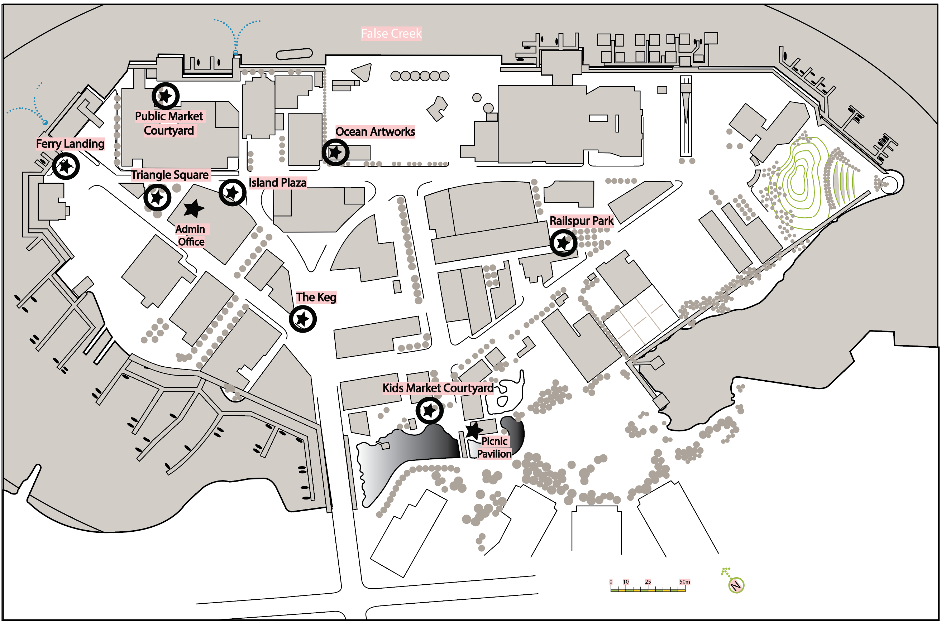

ACOUSTIC LICENSES

Musicians
A Musician, or musical act, is an individual, duet or trio of performers who play an instrument, sing, or a combination of both.

Variety Acts
A Variety Act, is a series of short performances or acts, such as comedy turns, up-close magic, etc. A Variety Act may also be a musician or musicians with a dancer or dancers if the total number of buskers is a maximum of three performers.
Variety Acts do not include the use of dangerous props in the show and therefore do not need a clear separation between the audience and the performer.

Individual Acts vs Group Acts
Acoustic License holders may perform as individuals, duets, or trios. Whether busking as an individual or as part of a duo/trio, the one-set-per-location-per-day policy still applies. If the number of buskers wishing to perform in a single timeslot is four or more, they must apply to the program for a Group License.
All Indoor Acoustic Busking locations are only available to solo performers. Duets, trios or groups may perform at Outdoor Acoustic Busking locations only.

Indoor Acoustic Locations
There are three indoor busking locations within the Public Market and the Net Loft:

1) Net Loft | 11:00am-5:00pm
2) Blue Parrot | 10:00am-6:00pm
3) Petit Ami | 10:00am-6:00pm

Outdoor Acoustic Busking
There are three outdoor acoustic busking locations around Granville Island:

- Kids Market Courtyard (must attend Morning Draw to sign up) | 11:00-8:00pm
- Island Plaza (alternates with amplified) | 11:00am-8:00pm
- Railspur Park (alternates with amplified) | 11:00am-8:00pm

Sign-up is in person only and spots are available on a first come, first served basis. Agents or representatives are not allowed to sign up on a busker’s behalf. Buskers may sign up for one set per location, per day.

APPENDIX: INSTRUMENT LIMITATIONS
CMHC-Granville Island reserves the right to limit the total number of licenses available for certain instruments and performance types. For instrument-specific limitation, please see below:

Accordions
Locations may be restricted.

Amplified Flutes
There are a limited number of amplified flute licenses available each year. Licenses are available on a first-come, first-served basis. If all licenses are taken there will be no more available that year unless one is permanently released. Amplified flute performers must not play back-to-back at any location or at the same time at adjacent locations. Additionally, a set list must be submitted to CMHC-Granville Island at the time of registration.

Bagpipes
One license per year is available for bagpipers. Performance locations are limited to The Keg, Ocean Artworks, and Ferry Landing. Ocean Artworks is only available for bagpiping on weekends and holidays. If the one license is taken no more shall be available for the year unless that license is permanently released.

Brass Instruments
Permitted to play at outdoor locations only. Please refer to the Amplified Regulations.

Percussion Instruments
Percussion instruments will be allowed into the program on a case-by-case basis. Mutes or sound dampening materials may be required.

String Instruments
Violins, fiddles, cellos, and violas must not play back-to-back at any one location, indoor or outdoor.

Use of Backing Tracks
Backing tracks and/or music samples used as accompaniment must be submitted to CMHC-Granville Island for approval. Backing tracks must enhance but not create the musical experience. They must be original and created by the user. They must never carry the melody or solo line. Karaoke-style accompaniment will not be accepted.

APPENDIX: NON-MUSICIAN LIMITATIONS
CMHC-Granville Island reserves the right to limit the total number of licenses available for certain performance types.
Licenses will not be issued to artists who provide a service or produce a physical product, including:

- psychics and/or tarot card readers
- balloon artists
- roving artists
- face-painters
- portrait artists
- painters
Busking licenses will not be issued to individuals, clubs or companies wanting to promote their business or activities or fundraise on behalf of another individual, organization, or entity even if they are engaging in a public performance to do so.
In addition, busking performances on Granville Island must not involve advertising, canvasing, political or religious issues, or rallying.

APPENDIX: ELECTRICAL POWER
Electrical power is available at the outdoor amplified locations. Buskers will need a minimum 50-foot extension cord to play at some of the locations. Buskers must ensure that their equipment, cables and cords meet current safety standards. CMHC-Granville Island reserves the right to disconnect any equipment that is likely to cause injury or damage. Cords or other equipment must not cross roadways or in any way interfere with the safe and convenient movement of pedestrians. Cords must not directly cross a pedestrian walkway.
The maximum number of speakers a busker may use is two. In addition, tops of speakers may not be more than a maximum of four feet from the ground.

On occasion, power may not be available due to maintenance, repairs or safety concerns. Power is available at the discretion of CMHC-Granville Island. No responsibility is assumed for any damage that may occur to a busker’s equipment – including damage or loss caused by interruption of power or disconnection or removal of equipment. Should a busker notice a problem with the power, they are to notify the Busker Coordinator as soon as possible to have the problem remedied.

APPENDIX: SOUND LEVELS (AMPLIFIED AND ACOUSTIC)
Busking activity on Granville Island must operate at a level where passers-by can carry a conversation at a normal volume.
The sound levels from a busking performance shall at no time disrupt businesses, whether retail or dining, affect workplace performance, or detract from the ambience of Granville Island’s public spaces.
Sound from busking must be maintained in accordance with the designated sound levels listed below:
Designation | dB Maximum | Location
Regular | 70 | Public Market Courtyard
 |  | Triangle Square
Lite | 65 | Island Plaza
 |  | Ocean Artworks
 |  | Kids Market Courtyard
 |  | Ferry Landing
 |  | The Keg
 |  | Railspur Park
Regardless of the sound levels noted above, if the noise output has generated complaints and is determined to be intrusive, the busker must reduce the volume to an acceptable level or be required to cease performance immediately.
An enthusiastic audience or an increase in another performer’s volume levels are not valid reasons for exceeding the designated sound levels.
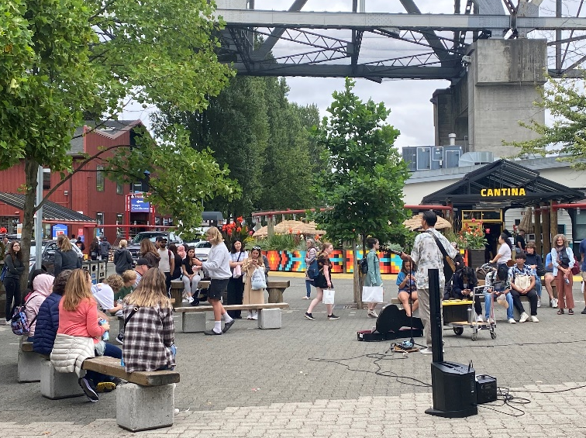
Amplification is a privilege on Granville Island. Amplification must be used only in designated areas and must be used with care and consideration for visitors, tenants and nearby residents. Once accepted into the Busking Program, during a buskers first performance at an amplified and amplified lite location, level setting will occur and be documented on a busker license file. Changing equipment will require a new level set. Buskers must comply with requests to reduce their volume.

APPENDIX: FIRE & DANGEROUS PROPS
Circle and Variety Act performers must retain complete control of every aspect of their performance. CMHC-Granville Island reserves the right to refuse a busker permission to perform, or to halt a performance if the use is considered unsafe.
The Public Market Courtyard is the ONLY location where buskers may include fire in their performance. After conducting a site visit, the Special Events Division of Vancouver Fire and Rescue Services identified this specific location as compliant with safety standards.

Dangerous props may be used at the Public Market Courtyard and Triangle Square.
In all locations, a defined separation of a minimum 3 meters must be created and maintained between the performer & prop and the audience.
Buskers are responsible for all injuries or damage to persons or property. Buskers using dangerous props and/or fire MUST complete Fire and Dangerous Props Declaration and submit all required safety documentation:
- A written safety plan indicating how they will ensure health and safety guidelines will be followed
- A site plan if their set and/or prop pieces are larger than a single suitcase
- Signed copies of CMHC safety maps of each location they wish to perform at
- A $5 million insurance policy listing CMHC-Granville Island as additional insurers
- A full list of fuel types used
- Prop storage/safety precautions
In the event of an emergency, the busker must call 911, then Granville Island Security at: 604-315-3003.

